JalinkLab easy microscope climate controller (e_mc²)

Overview
<Photo of the nextion screen>
Cheap but fully functional touch-screen system to control the climate in your microscope enclosure/incubator. Keep your cells alive, and as happy as they would be in the culture incubator, right on the stage of your microscope. The system is capable of controlling temperature, humidity, Lens temperature and CO₂ (T, H, L and C respectively) actively using 4 separate PID (Proportional Integrating Differentiating, link**) control loops in stage top incubators of full microscope enclosures. E_mc2 is a stand-alone system that allows the user to set target values for T, H and C and graphs the actual values of these parameters over an adjustable time window. Moreover, e_mc2 can be interfaced to any PC Com port using a USB cable, allowing logging of T, H and C if needed.
We provide a simple step-by-step plan for building one yourself at less than 5% of the typical costs for a commercial system. The system we use in our lab is a 4-channel regulator, but with minimal programming skills, users can extend the system to include additional channels, such as O₂ levels (for hypoxia experiments) etc.
<schematic of the whole system><some photo of Rolfs enclosure>

Bill of materials
Outlets for compressed air (>1 bar) and CO2 (>0.5 bar) and optionally N₂
Esp32. Solder a C from pin * to *
HYT
CO2
3x led, resistors, C
Tubing, wires, suitable housing e.g. link to lasercut

General description:
At the heart of the system is the ESP32 controller (DOIT ESP32 DEVKIT V1, link to source) loaded with the sketch presented here** or downloadable from the Gitlab here **. It is hooked up to a Nextion Human Machine Interface touchscreen (NX8048P070-011C-Y, link **) which is loaded with firmware developed in Nextion Editor link** which can be found here ** or in the Github.
In normal operation, the ESP32 reads sensors, calculates and outputs updated control values like heater power (blue) and sends data to the screen (2), and the Nextion passively displays this information. The situation is more complex when the user wishes to alter the settings. The Nextion is an intelligent screen with plenty of processing capabilities, and to combine rapid screen handling with minimal load for the ESP32, the Nextion handles quite a bit of the functionality. For example, when the user changes temperature setting, this is done via the Nextion touch screen (and NOT via the ESP32), and the Nextion handles data validity check, checks parameter save limits, and updates other dependent fields on the screen (5). This setup limits hardware costs, but the consequence is that the user must then finalize the updated settings by expressly instructing (3) the Nextion to transfer this information to the ESP32. From that time on, the ESP32 will sent measurement data to Nextion based on the new settings. Thus, in this layout the Nextion firmware and the ESP32 sketch (firmware) together control operation of the controllers, although the ESP32 does the heavy lifting of calculating PID values, of reading out the sensors and of outputting the various digital and analog control voltages.
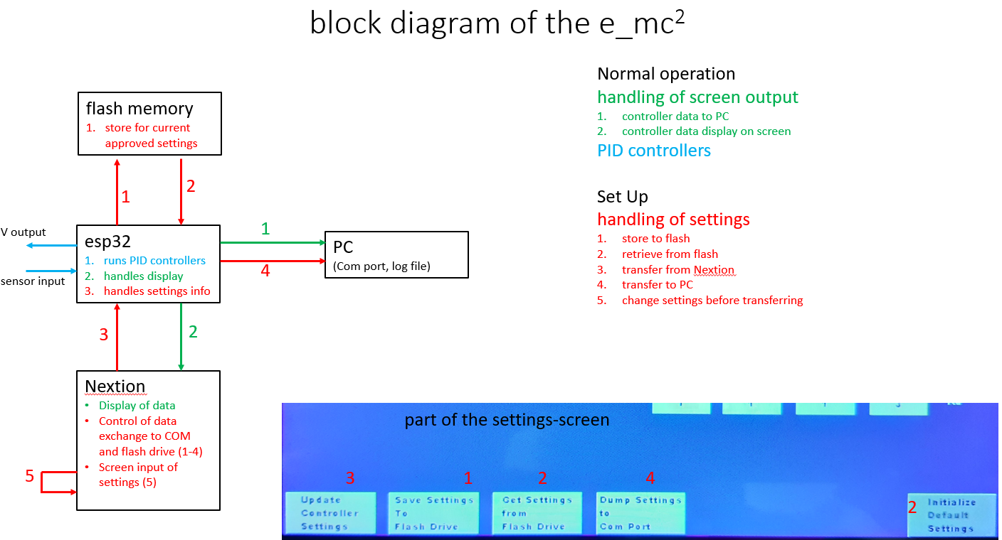
The ESP32 is capable of stand-alone operation (5V external voltage needed) or may be operated via the USB port of a PC. In the latter case it can also log data (1) or settings (4) (either in simple or verbose mode) to a COM port, for example by enabling the Serial Monitor function in the Arduino development software (link **). However, further handling and plotting of such log files (csv format) is user responsibility.
Finally, it is important to note that the user settings are stored (1) on the ESP32 integral flash drive. This serves to assure that following a power interruption the e_mc² controller continues with the most recent user settings and PID parameters. However, content of graphs and log files are not kept during a power interruption. The user normally alters settings (temperature, graphing speed, communication settings) (5) and test-drives the controller until he is content. At this point, settings are still ONLY in the ESP32 and Nextion, and the user has to expressly instruct saving (1) these settings to the flash drive.
Upon powering up the device, settings are always read (2) from the flash drive. If needed, the user can also recover settings from the flash drive during normal operation, which is useful e.g. when experimenting with new settings gives erroneous results.
Electronic circuit:
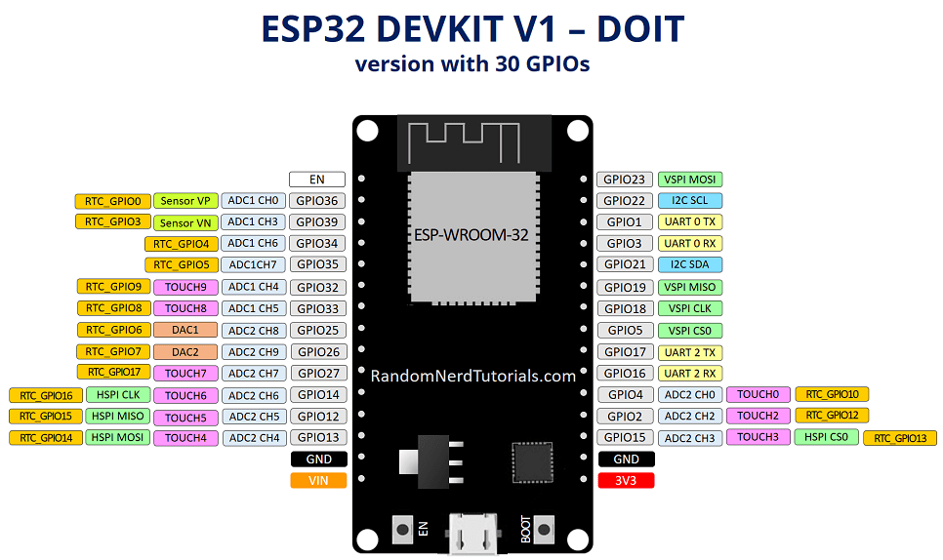
Basic connections for 4 PID channels are shown in the next figure. Connections are so simple that they can be build up and tested on a breadboard, although making a simple PCB is recommended for mechanical stability.
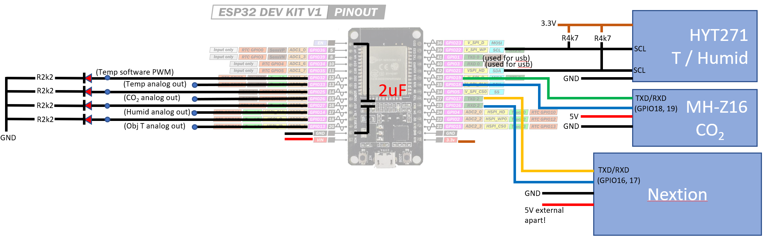
In brief, these parts constitute the whole system:
The ESP32 microcontroller receives input from the HYT271 Main Temperature/humidity sensor, from the MH-Z16 CO2 sensor (0-100,000 ppm type! There are other types with lesser range) and from the Objective T sensor (second HYT271 for uniformity). It calculates PID outputs and delivers those as both 4 ‘analog’ channels of output (0-5V delivered as fast PWM using the ESP32 functionality) as well as 4 slow software-encoded PWM channels. The latter are suitable for slow (e.g., once per 15 s) digital control of switching heaters, CO@ valves etc, to prevent excessive switching and thus, wear. Software PWM works at a fixed frequency (1/15Hz default; this can be edited by altering variables in the Arduino sketch) and regulation is via pulse witdth modulation, duty cycle ** to 100%. Finally, the ESP32 talks to the Nextion interface, sending measurement data, activating alarms, and receiving settings info as detailed under General Description.
According to the manufacturer, it is essential that the Nextion is powered from a separate very stable 5V power supply and NOT from the same USB voltage as the ESP32. Stand-alone operation (without USB connection) is best achieved my deriving two separate stabilized 5V outputs from a power supply, e.g. using two LM317 circuits. Power consumption is ** mA max. This configuration also prevents resetting of the e_mc2 device when the computer is restarted.

The code
Include libraries
Arduino environment

See: https://randomnerdtutorials.com/install-esp32-filesystem-uploader-arduino-ide/
For a method to upload the settings file to esp32 flash memory
//make sure the tool esp32FS.jar is in the arduino tools folder see https://randomnerdtutorials.com/install-esp32-filesystem-uploader-arduino-ide/
//in the folder of your sketch you should create a folder called "data" (verbatim). And in that, create a txt or json file e.g. tst.txt with some string content
//Finally, use "Tools/esp32 Sketch data upload" to upload the file

